Evidence Output

T013:

Valid address case.

Input Pekan Nanas Johor in address case.

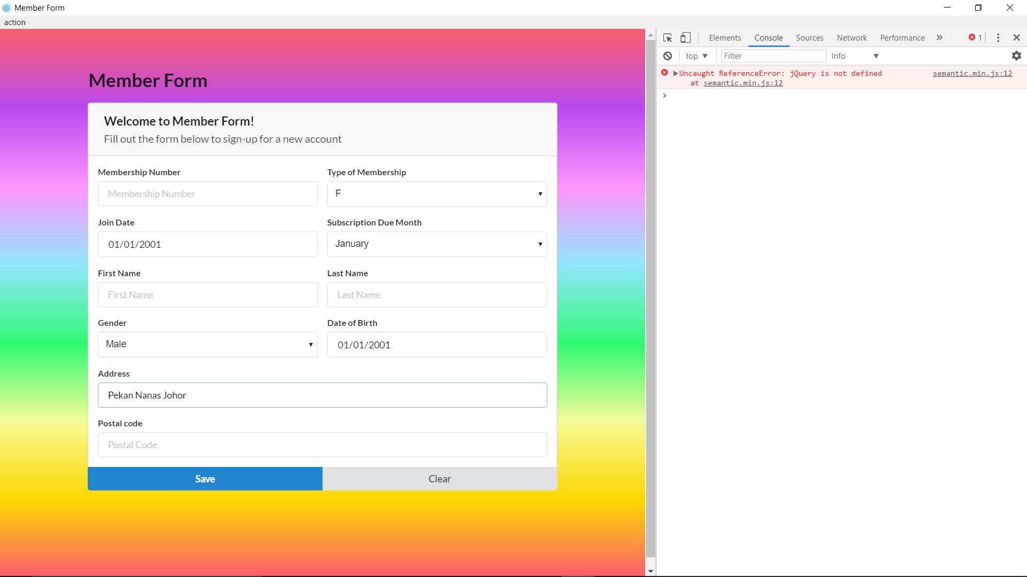

Valid address case success.

